2020 Chesuncook Lake Salmon Derby Rules
This derby is for landlocked salmon caught in Chesuncook Lake, Caribou Lake, and Ripogenus Lake. All fish entered in the derby must be caught between 12:01am Saturday, Sept 5th and the close of the derby at 6:00pm on Sunday, Sept 6th. You must be in line at 6:00pm on Sept 6th to have your fish weighed to be included in the derby. Derby ticket sales end at 12:00pm on Saturday Sept 5th. You must have a valid entry form to have your fish weighed.
Fish can be weighed in at the Maine Forest Service barn adjacent to the boat launch on Chesuncook Lake. The weigh station will be open from 3:00pm to 7:00pm on Saturday and 3:00pm to 6:00pm on Sunday.
A $500 prize will be given to the participant that enters the largest salmon. Winners will be ranked by weight. The first tiebreaker will be the longest length; second tiebreaker will be the earlier time weighed. Anglers will only be able to enter one salmon 16 inches and over in the derby. The winner will be required to sign an affidavit that he/she caught the fish, and it was caught in Chesuncook, Caribou, or Ripogenus Lake during the hours of the derby. The winning fish may be retained and examined by the Judges and Maine Department of Inland Fisheries and Wildlife. In all matters, the decision of the derby judges will be final.
A $500 prize and possibly other prizes will be randomly selected from the fish pool tickets. Anglers will be given a ticket for each salmon under 16 inches they bring to the weigh station. These tickets will create the fish pool. The fish pool prizes will be drawn at the conclusion of the derby and the winners will be notified by phone. You do not have to be present to win. There is no size or bag limit on salmon under 16 inches on Chesuncook, Caribou, and Ripogenus Lakes. We are encouraging anglers to harvest these smaller salmon. This is the primary purpose of the derby.
All Maine Fishing Regulations must be followed and the winner will be required to provide proof of a valid fishing license.
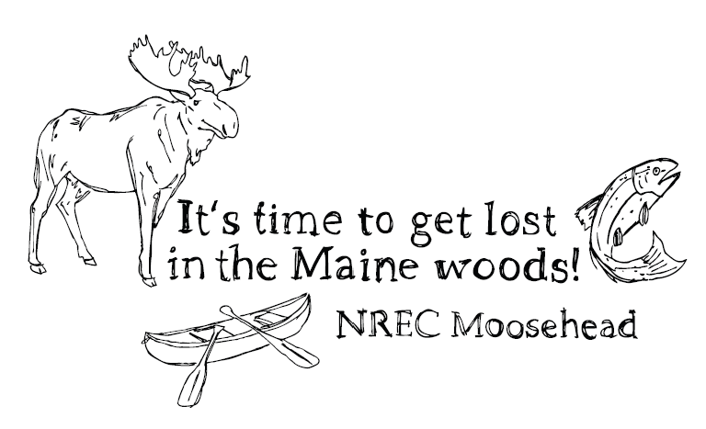
Ticket sale locations:
Indian Hill Trading Post – Greenville
Two Rivers Canoe and Tackle – Medway
Allagash Gateway Campground – Chesuncook Lake
Or online at: www.NRECmoosehead.org

The Maine Department of Inland Fisheries and Wildlife (MDIFW) is partnering with the Natural Resource Education Center at Moosehead (NREC) to develop a salmon fishing derby on Chesuncook Lake, including Ripogenus Lake and Caribou Lake. The derby is one strategy of a management plan to restore the quality wild salmon fishery that was prevalent on Maine’s third largest lake for decades.
Prior to the mid-1990’s, Chesuncook Lake and the West Branch of the Penobscot River above the lake (i.e. The Foxhole) and below Rip Dam were some of the best quality salmon waters in Piscataquis County. In 1994, more restrictive regulations were put in place to protect the high-quality fishery. However, soon after, angler use declined as the mills in Millinocket shut down and there were fewer anglers in the area making the trip to Chesuncook Lake. The combination of restrictive regulations and lack of angler use and harvest, resulted in the stockpiling of salmon. The MDIFW has documented declining salmon growth and an abundance of smaller salmon in the lake.
In 2018, the MDIFW implemented new salmon regulations to increase the harvest of smaller salmon. The regulations include: No size or bag limit on salmon under 16 inches and a 1 fish bag limit on salmon greater than 16 inches. The MDIFW has a harvest goal of 2,000 salmon per year until growth recovers. In 2017, the estimated salmon harvest was just 400 fish. Therefore, there is a need to attract more anglers to the lake and to encourage them to remove more salmon to reach this goal.
This situation is comparable to Moosehead Lake in the 1990’s and early 2000’s with lake trout. In 2008, the MDIFW developed a similar management strategy that included very liberal regulations on small lake trout and a large winter ice fishing derby to attract anglers. It worked very well.
The Chesuncook Lake Salmon Derby will be held on the Saturday and Sunday of Memorial Weekend. A cash prize of $500 will be given to the angler that enters the largest salmon of the derby. Also, anglers will be given one raffle ticket for each salmon under 16 inches that they bring to the weigh station. Another $500 cash prize and possibly other prizes will be drawn randomly from these raffle tickets. This will encourage anglers to harvest smaller salmon.
Any funds raised from the derby will go to NREC. NREC is an educational 501(3)(c) that provides outdoor youth programs, college internships, organizes the annual Moosehead Lake Togue Derby with Ricky Craven and the Thoreau-Wabanaki Trail Festival, adult nature-based programs, and other community functions in the greater Moosehead Lake area. NREC also recently constructed the Moosehead Lake Visitors’ Center and the newly restored Big Moose (Squaw) Mountain Fire tower at the entrance to Greenville. You can learn more about NREC at: www.NRECmoosehead.org

